English 11
Course Outline
Mrs. Giczi 2018/2019

Introduction
Your course will cover five (5) units:
- short stories - drama study – Macbeth
- essays - novel study – Lord of the Flies
- poetry

Course Description:
“The aim of English Language Arts is to provide students with opportunities for personal and intellectual growth through speaking, listening, reading, viewing, writing, and representing to make meaning of the world and to prepare them to participate effectively in all aspects of society" (Ministry of Education).

At the beginning of each unit, you will be provided with an outline for that unit, along with the accompanying assignments (including the final assessment activity). Teacher instruction and class discussion will occur daily. While time will be made to work in class, you will be expected to work and read independent of class time.

Timeline of Course:
Each of the five units will be covered in approximately three weeks.

Resources required:
The teacher will provide all group reading materials. Students are expected to have an independent reading book of their choice at class every day. Students are also expected to have a binder with a supply of lined paper for each class.

Class Expectations: Student Responsibilities
- To attend school everyday (unless too ill to do so)
- To participate thoughtfully in class discussions
- To bring the required tools and equipment to class
- To make an honest effort every class and to complete all assignments to the best of their ability
- To review the feedback given on assessed assignments and complete corrections as required
- To complete and hand in assignments on time (unless otherwise negotiated beforehand with the teacher)
- To ask the teacher if there is anything that you do not understand, including meeting with the teacher after school, if necessary
- Students are not to use cell phones or music players in class
- Plagiarism and cheating will not be tolerated. Students will receive a mark of zero.
- Be polite and respects other’s opinions

Assessment and Evaluation Plan:
The evaluation process in this course involves self-evaluation, peer-evaluation, and teacher evaluation of student work. Many assignments will be marked formatively (comments given with no % grade assigned). Once students have developed and improved upon skills, more summative (graded according to a rubric) evaluation will occur. Written assignments will be marked using the BC Performance Standards Quick Scale rubrics. Students will be given a copy of these rubrics before assignments.
Students with good attendance will have the opportunity to redo most written assignments in order to improve their mark.
Weighting of grades in the course: Reading and Viewing 37.5%
Writing and Representing 37.5%
Speaking and Listening 5%
final exam 20%

The provincial curriculum divides all English course work into six areas: reading, viewing, writing, representing, speaking, and listening.

Reading and Viewing: Students will
- Read and view a variety of texts with increasing complexity
- Read for enjoyment and to increase fluency
- Use strategies before, during, and after reading/viewing to anticipate content and extend meaning
- Describe personal connections to texts, and evaluate ideas and information in them
- Extend thinking by contextualizing what has been read
- Reflect on and assess their reading/viewing skills and set goals for improvement
- Recognize and explain how text structures and features enhance understanding of text
- Demonstrate increased skill in using vocabulary specific to task and purpose

Writing and Representing: Students will
- Create a variety of texts for a variety of purposes
- Use a range of strategies to increase success at writing and representing
- Use writing and representing for personal responses, to evaluate ideas/information, and synthesize/extend thinking
- Reflect on and assess their writing/representing skills, and set goal for improvement
- Use elements of style, form, and conventions appropriate to purpose/audience to enhance writing

Oral Language – Speaking and Listening: Students will
- Use oral language to collaborate effectively in a variety of situation
- Express themselves with confidence and listen critically
- Effectively adapt and apply speaking and listening strategies to explore multiple perspectives
- Prepare and deliver oral communications
- Analyze and critique information
- Use oral language with precision to connect to, analyze, and evaluate a variety of texts to synthesize and extend thinking
- Reflect on and assess their skills, and set goals for improvement
- Recognize and apply the structures and features of oral language with increasing sophistication

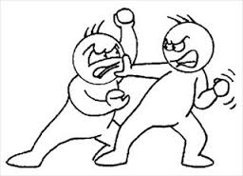
Big Question:
Where does conflict come from?

Unit One – Short Stories
Overview
This unit looks at a range of short stories and essays on a variety of themes and in a variety of styles. Emphasis is placed on the structure of each of these types of writing. Literary terms, plot structure and essay techniques are studied. Students apply their understanding of these concepts to reading, analyzing, and responding to other short stories and essays. Students are encouraged to respond to themes and agreements from a personal perspective.

Lesson 1 – Elements of a short story (flashback and allusion)
- Elements of short stories – handout/assignment
- Story: Mirror Image by Lena Coakley
- https://www.youtube.com/watch?v=54MqTST40gc

Lesson 2 – Irony
- Irony handout/assignment
- Story: The Prospector by Cathy Jewison
- http://examples.yourdictionary.com/examples-of-irony.html
- https://www.youtube.com/watch?v=FYq2d7iKKhk
- https://www.youtube.com/watch?v=tqg6RO8c_W0
- https://www.youtube.com/watch?v=RZFYuX84n1U
- https://www.youtube.com/watch?v=IiR-bnCHIYo

Lesson 3 – Characters & Characterization (stereotypes and symbolism)
- characters handout/assignment
- https://www.youtube.com/watch?v=j_mdG6azrMA
- https://www.youtube.com/watch?v=56TKTf5wkws

Lesson 4 – Plot
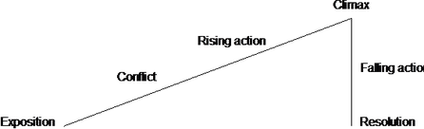
- Story: The Maiden Wiser than the Tsar folktale
- Story questions
- https://www.youtube.com/watch?v=cX1squb4PiI
- https://www.youtube.com/watch?v=O5nciEKwwQ4

Lesson 5 – Point of View and bias
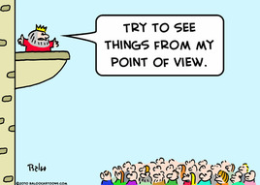
- handout
- Story: The Pose by Andrew Khan
- https://www.youtube.com/watch?v=kuvJbzMLz-M

Lesson 6 – Satire, Allegory and Symbols
- Story: The Elephant by Slawomir Mrozek
- https://www.youtube.com/watch?v=8M-KlV5cPUo
- https://www.youtube.com/watch?v=CZGIn9bpALo
- https://www.youtube.com/watch?v=vNy-7jv0XSc

Lesson 7 Conflict
- Story: The Test by Theodore Thomas
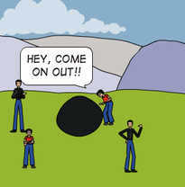
- Handout/assignment

Lesson 8 Theme Statements
- Story: He-y, Come on Out! by Shinichi Hoshi
- Handout/assignment
- Inverted sentences worksheet
- https://www.youtube.com/watch?v=H3_Bb9wGObY

Culminating Essay
- assignment
- rubric

Unit Test – Review
- review

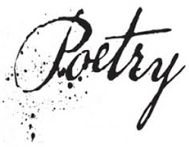
Big Question: How Can Poetry Allow Us to Express and Reflect on Emotions, Ideas, and Issues?

Unit Two – Poetry
Overview
By the end of the unit students will:
- Learn/review poetry terms, the specific terminology poets use when they talk about poetry
- Read poems that illustrate this terminology, a variety of poetic types, and universal themes
- Complete a variety of assignments to accomplish these goals
- Create a personal poetry journal
- Show your mastery of poetry terms, elements and poetry analysis on a unit test

Lesson 1 – Intro to Poetry
- The Power of Poetry PowerPoint
- Poetic devices handout and worksheet
- TIME/ Poetry Is... handout/assignment
- Analysing poetry
- Poem analysis sheets
- Video: analysing an unseen poem – GCSE
- Video: How to analyse a poem you've never seen

Lesson 2 - Lyric Poems
- Go Figure PowerPoint
- Figurative language worksheet
- Poem or lyric? assignment
- "Sympathy" worksheet
- Journal assignment
- Lyric poetry worksheet
- Videos – figurative language (X3)

Lesson 3 - Sonnets
- Shakespeare sonnet handout
- Sonnets worksheet
- Sonnets rubric
- Sonnets assignment
- Videos – Scansion 101; Learning Iambic Pentameter; Why Shakespeare Loved Iambic Pentameter; How Do I Love Thee; Shakespeare Sonnet #130; Shakespeare Sonnet #116; Shakespeare Sonnet #55
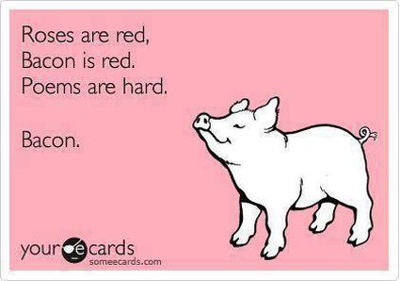
Lesson 4 – Light Verse
- Light verse worksheet
- Light verse handout/assignment
- Videos – How To Write A Limerick; Limerick #1; Limerick #2; Limerick #3

Lesson 5 – Satirical Poetry
- Satirical poetry handout 1
- Satirical poetry handout 2
- Symbolism assignment
- Video – Satire – School Lunch

Lesson 6 – Pantoum
- Pantoum planning worksheet

Lesson 7 – Symbolism
- Robert Frost symbolism worksheet

Lesson 8 – Elegy and Ode
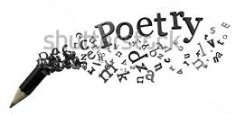
- Ode and Elegy handout & assignment

Lesson 9 – Descriptive Poetry
- Descriptive poetry handout
- Descriptive poetry worksheet
- Descriptive poetry assignment
- Illustrate poetic devices assignment
- Denotation and connotation worksheet

Lesson 10 – Narrative Poetry
- Narrative poetry handout
- Narrative poetry assignment

Lesson 11 – Performance Poem Assignment

Culminating Activity
- Culminating activity assignment

Test

Big Question:
What makes goo Big Question:
What makes good people do
bad things?
d people do
bad things?

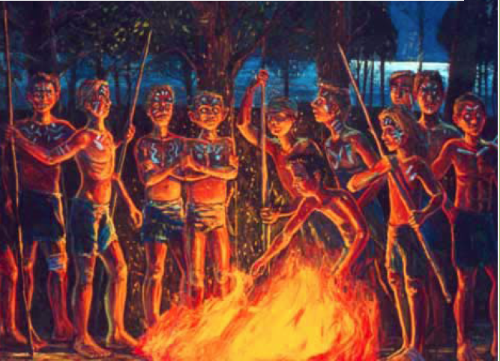
Big Question:
What makes good people do bad things?

Unit Three – Novel Study
Overview
On a literal level, Lord of the Flies deals with what happens to a group of boys stranded on an island with no adult supervision. On a symbolic level, Lord of the Flies investigates what happens to civilized people when the structures of civilization disappear.
Through reading and discussing the novel, and completing assignments, students will focus on what happens on the literal level in the book and what those developments means on the symbolic level. That is, what happens literally to the boys, and what is the author saying metaphorically about the structures of civilization? Students will also explore the themes of power, control, abuse and respect between the characters in the novel.
Students will also participate in an on-line survival game in small groups. The game typically takes 4 – 5 sessions. It will be played until one of the groups is ‘rescued.’

Lesson 1 – Introduction
- Anticipatory Guide
- Trapped on a Shelter
- Background information – William Golding Biography
- Cold War & McCarthyism

Lesson 2 – Chapters 1 & 2
- Predictions worksheet
- Handout – LOTF vocabulary
- Worksheets – whole novel – Questions Raised During Reading
- Quotes – Complete the Grid
- Major conflicts within the novel
- Character Log
- Themes in the novel
- Leadership within Lord Of The Flies
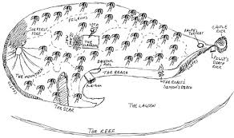
- Read chapters 1 & 2
  - Comprehension questions
- Worksheet - Mapping – art assignment
- Quiz – Test Your Knowledge

Lesson 3 – Chapters 3 & 4
- Read chapters 3 & 4
  - Comprehension questions
- Worksheet – Fear
- Quiz – Test Your Knowledge

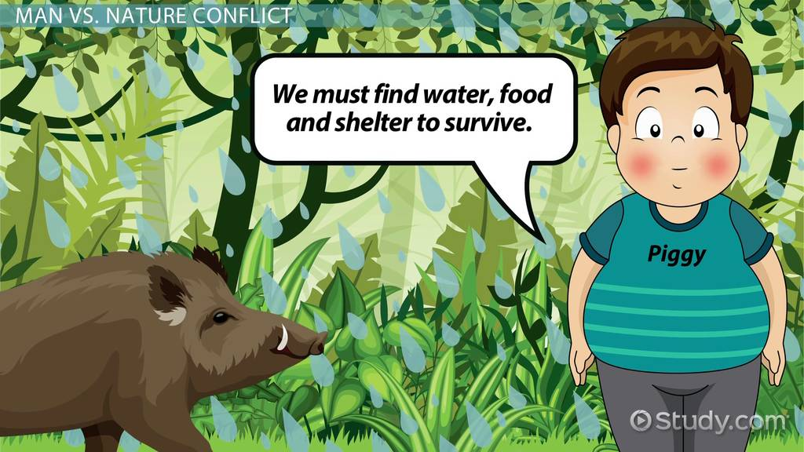
Lesson 4 – Chapters 5 & 6
- Read chapters 5 & 6
  - Comprehension questions
- Worksheet – Tension and Conflict
- Quiz – Test Your Knowledge

Lesson 5 – Chapters 7 & 8
- Read chapters 7 & 8
  - Comprehension questions
- Worksheet – Figurative Language (simile, metaphor, personification, hyperbole)
- Quiz – Test Your Knowledge

Lesson 6 – Chapters 9-11
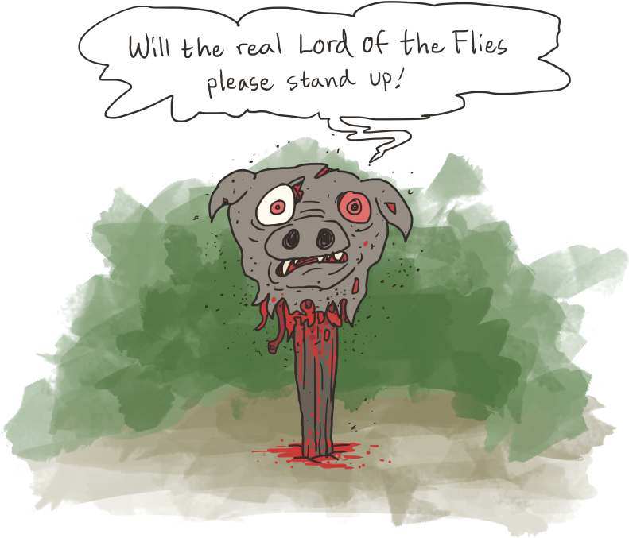
- Read chapters 9-11
  - Comprehension questions
- Handout – How to Analyze Symbolism in 8 Easy Steps
- Worksheet – LOTF Symbolism
- Quiz – Test Your Knowledge

Lesson 7 – Chapter 12
- Read chapter 12
  - Comprehension questions
- Worksheets – Things Fall Apart: The Centre Cannot Hold
- The Ending of the Novel
- Quiz – Test Your Knowledge

Lesson 8 – Synthesis
- Upon Their Return: Newspaper Article

Lesson 9 – Review
- Review Game

Test

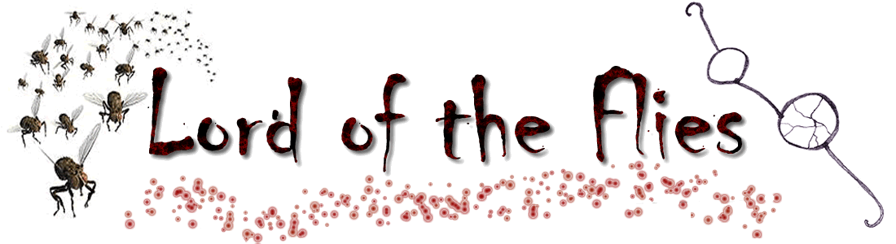

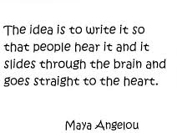
Big Question: How Can I Get My Point Across Effectively?
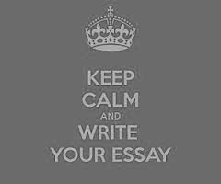
Unit Four – Essays
Overview
This unit looks at different types of essays, their differing styles and uses.

Lesson 1 – Literary & Critical Analysis Essay
- Types of Essays handout 1
- Types of Essays handout 2
- Types of Essays handout 3
- Literary essay rubric
- Reading: In Support of Nick Bantock's "Life Class"
- https://www.youtube.com/watch?v=-lzGy5gizKg
- https://www.youtube.com/watch?v=V1pnpL8295E
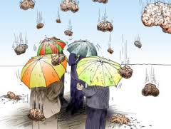
- https://www.youtube.com/watch?v=cuY4zQnwL4A

Lesson 2 – Personal Essay (Narrative)
- Similes and metaphors handout/assignment
- Reading: The Shack
- Brainstorming handout
- Personal essay rubric
- https://www.youtube.com/watch?v=JcdndYPItHI

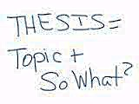
Lesson 3 – Thesis
- Thesis handout
- Reading: It's Time to Think About Visors
- https://www.youtube.com/watch?v=Nx2-PcBzZjo
- https://www.youtube.com/watch?v=8wxE8R_x5I0

Lesson 4 – Argumentative Essay "Fact & Opinion"
- Reading: Whose Lathe?
- https://www.youtube.com/watch?v=V1pnpL8295E
- https://www.youtube.com/watch?v=-lzGy5gizKg

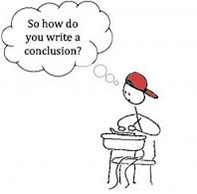
Lesson 5 – Essay Introductions & Conclusions
- Reading: Progress
- Intros and conclusions handout
- https://www.youtube.com/watch?v=Rkefst9D6n0
- https://www.youtube.com/watch?v=npjqdj-gR8o
- https://www.youtube.com/watch?v=2L7aeO9fBzE
- https://www.youtube.com/watch?v=tR4uxPfG21A

Lesson 6 – Essay Composition and Techniques
- Transitions handout
- Composition techniques handout
- Quotations worksheet
- https://www.youtube.com/watch?v=v3OZn29K93s
- https://www.youtube.com/watch?v=5aC6qT8WB8c
- https://www.youtube.com/watch?v=uHMR2ZhP6vY

Culminating Essay
- Culminating Essay assignment – The Good VS Evil Debate (refer back to LOTF novel)
- Essay rubric

Test Review
- Test review handout

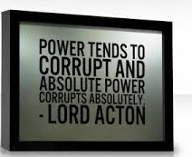
Big Question:
What does this play teach
Us about leadership and power? Is this still relevant today?

Unit Five – Macbeth
Overview

Lesson 1 – What do you know about Shakespeare?
- What do you know about Shakespeare? Handout (3 parts)
- https://www.youtube.com/watch?v=P0SBg-KG4C4
- https://www.youtube.com/watch?v=9oPe7tG0vYs
- https://www.youtube.com/watch?v=ZEWA59LAIjg
- https://www.youtube.com/watch?v=K-aAUwAFZlQ
- https://www.youtube.com/watch?v=JZnqU0ypQ-I

Lesson 2 – Shakespearean Language & Intro to Macbeth (Act 1, Scene 1)
- Macbeth overview PowerPoint
- Macbeth study guide assignment
- Journal entry #1 – "Greed is the root to all evil." Comment on this quote. What does this phrase tell us about human nature? Is it good to have ambitions? What do you think this has to do with Macbeth?
- https://www.youtube.com/watch?v=BMkuUADWW2A
- https://www.youtube.com/watch?v=rFtCYESosDw
- https://www.youtube.com/watch?v=uzAujyWpK_s

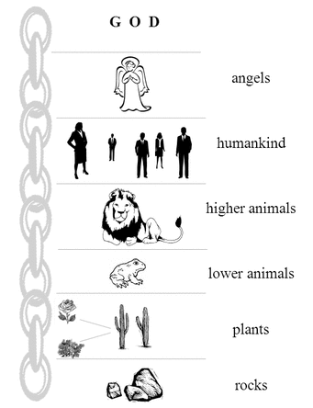
Lesson 3 – The Great Chain of Being (Act 1, scene 2-3)
The Great Chain of Being details a strict, religious hierarchical structure of all matter and life, believed to have been decreed by God. The chain starts from God and progresses downward to angels, demons (fallen/renegade angels), stars, moon, king, princes, nobles, men, wild animals, domesticated animals, trees, other plant, precious stones, precious metals, and other minerals. (http://en.wikipedia.org/wike/Great_chain_of_being)
- Great Chain of Being PowerPoint
- Journal entry #2 – How does the Great Chain of Being relate to the Gothic Era and Macbeth?
- https://www.youtube.com/watch?v=XHjRtXokQwQ
- https://www.youtube.com/watch?v=r_oGLGqPTCE

Lesson 4 – Soliloquies & Stereotypes (Act 1, Scene 4-7)
- Stereotypes and Theatrical Conversations handout
- Macbeth Act 1 questions
- Journal entry #3 – Describe Macbeth's and Lady Macbeth's personalities based on their speeches
- https://www.youtube.com/watch?v=D1-aSIUP4wM
- https://www.youtube.com/watch?v=XjJQBjWYDTs
- https://www.youtube.com/watch?v=wRRx-7fAEwA
- https://www.youtube.com/watch?v=q1yz-NLJZwE
- https://www.youtube.com/watch?v=Ojo3ik8M6Bk

Lesson 5 – Quotes & Point of View (Act 2, Scene 1 – 2)
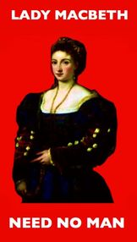
- Quotes and POV assignment
- Journal entry #4 – Write a journal entry from Lady Macbeth's point of view – what are her thoughts and feelings at this point?
- https://www.youtube.com/watch?v=fI2hiQNiyW4
- https://www.youtube.com/watch?v=KbInLNRgxwM
- https://www.youtube.com/watch?v=1XWBsOcZMUA
- https://www.youtube.com/watch?v=Sck2bJPFDyw

Lesson 6 – Symbols (Act 2, Scene 3 - 4)
- Symbolism PowerPoint
- Journal entry #5 – Draw a symbol that you feel represents either Lady Macbeth or Macbeth, and write a well-structured paragraph defending you choice.
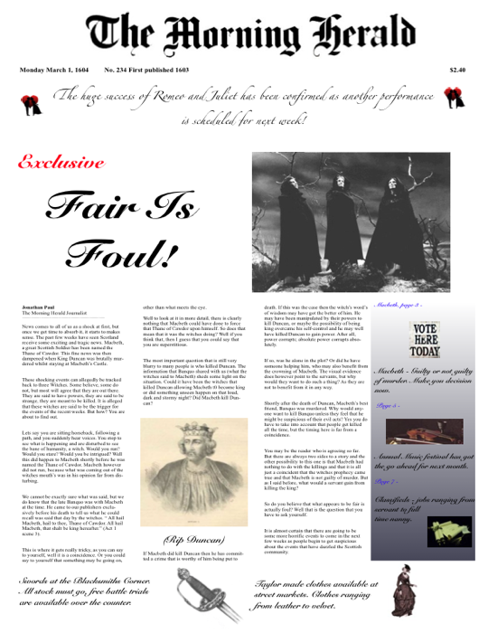
- Act 2 Questions
- https://www.youtube.com/watch?v=mnTEQCteQCE
- https://www.youtube.com/watch?v=L-1tuylKZl0

Lesson 7 – Headlines & Word Play (Act 3, Scene 1 – 3)
Figurative Language
- Figurative language handout
- Reading assignment
- Headlines word play assignment
- Newspaper article assignment
- https://www.youtube.com/watch?v=1RMOh0l4xZs

Lesson 8 – Shakespearean Tragedy and the Tragic Hero (Act 3, Scene 4-6)
- Tragic Hero PowerPoint
- Journal entry #6 – "What comes up, must come down." Write about this quote in relation to Macbeth and the Tragic Hero.
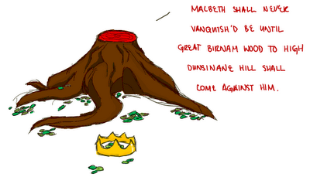
- Reading assignment
- Act 3 questions
- https://www.youtube.com/watch?v=NWbxpK90I_Q
- https://www.youtube.com/watch?v=2LKMktAN4hc
- https://www.youtube.com/watch?v=u-tD2t77RSQ

Lesson 9 – Themes and Motifs (Act 4, Scene 1 – 3)
- Theme & motif handout
- Key events handout
- Reading assignment
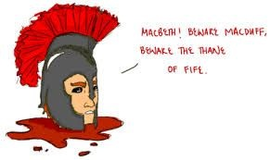
- Journal entry # 7 – Write an alternate Act 4 Scene 2, in which Macduff has secretly remained and appears to defend his family from attack. What would be the consequences, in this case, if one of the murderers survived?
- https://www.youtube.com/watch?v=quFamQW6QmI
- https://www.youtube.com/watch?v=UvqmTekrUBQ
- https://www.youtube.com/watch?v=JOztkiogc3Q
- Act 4 questions

Lesson 10 – Character Study (Act 5, Scene 1-5)
- Character study notes
- Quotes & characters worksheet
- Journal entry #8 – Use the character worksheet to create a character web for either: Macbeth, Lady Macbeth, or The Witches (to be used for final project later)
- https://www.youtube.com/watch?v=N7HYSrADXv8
- https://www.youtube.com/watch?v=Lub8cS5W3oc
- https://www.youtube.com/watch?v=zg5FuyPtvyw

Lesson 11 – This is the END – Power (Act 5, Scene 6-8)
Our Big Question: What does this play teach us about POWER, and is it still relevant today?
- Power revised PowerPoint
- Journal entry #9 – Write a review of the movie Macbeth
- Act 5 questions
- https://www.youtube.com/watch?v=HZnaXDRwu84
- https://www.youtube.com/watch?v=rvIHrd1ouX0
- https://www.youtube.com/watch?v=A_oM65J9EWY
- https://www.youtube.com/watch?v=IyytzE13iV4

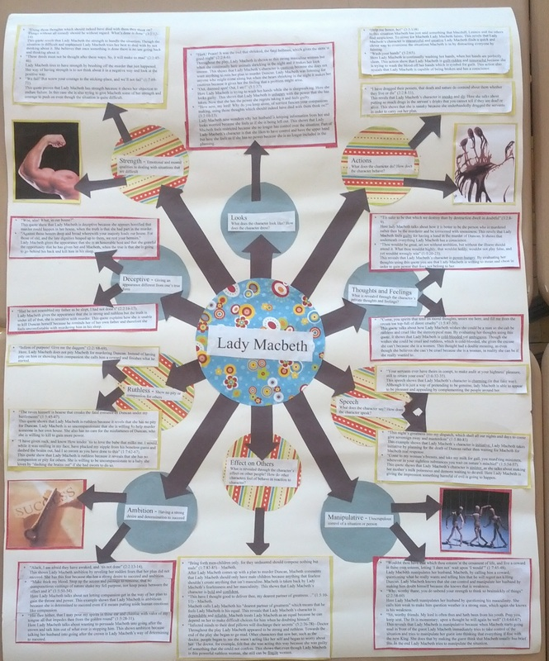
Lesson 12 – Culminating Activity: Character Map
- Character map assignment and rubric
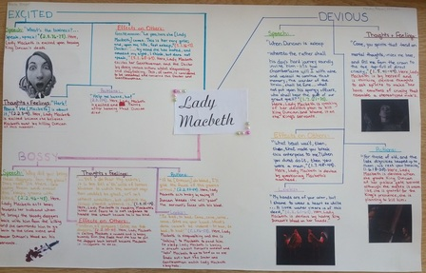

Test Review
- https://www.youtube.com/watch?v=T-PKotyoxys

Test

