Psychology 12
Course Outline
Mrs. Giczi 2018/2019

Description
This course introduces students to the study of human behavior and mental processes. Students will explore and apply psychological theories, key concepts, and phenomena associated with such topics as the biological bases of behavior, learning and cognition, motivation, testing and individual differences, and treatment of abnormal behavior.
The course information will be presented through lectures, class participation activities, demonstrations, and audio-visual aids. Students will use their text books and other resources such as the internet, popular media, and newspapers to conduct research throughout the year. Students will learn about the methods and ethical approaches of psychology.

Resources
Textbooks: Psychology: A Complete Introduction (PACI)
Psychology Made Simple (PMS)

Class Expectations: Student Responsibilities
- attend school every day (unless too ill to do so), bringing the required tools and equipment
- To bring the required tools and equipment to class
- participate thoughtfully in class discussions
- make an honest effort every class and complete all assignments to the best of your ability
- review the feedback given on assessed assignments and complete corrections as required
- complete and hand in assignments on time (unless otherwise negotiated beforehand with the teacher)
- ask the teacher if there is anything that you do not understand, including meeting with the teacher after school, if necessary
- Students are not to use cell phones or music players in class
- Plagiarism and cheating will not be tolerated. Students will receive a mark of zero.
- Be polite and respects other’s opinions

Assessment and Evaluation Plan
- Grades will be determined by your performance on quizzes, tests, assignments, projects and other classroom activities. Final exam is worth 20% of your mark. Final Project is worth 10% of your mark.
- Weighting of grades in the course is:
- quizzes/tests/summative assessments 20%
- assignments 50%
- final project 10%
- final exam 20%

Proposed Time Line (Each unit to be approx. 2 - 3 weeks)
Unit 1 - Introduction; History of Psychology
Unit 2 - The Brain
Unit 3 - Learning
Unit 4 - Thinking
Unit 5 - Intelligence and Testing
Unit 6 _ Personality
Unit 7 – Abnormal behaviour
Catch-up, Review, and final project work

Unit One - Introduction
Overview
This unit will describe and define psychology. It also identifies and describes the early pioneers and schools of thought in psychology. This unit also focuses on the current perspectives in psychology including psychoanalysis, behaviorism, humanistic psychology, psychobiology, and
sociocultural psychology.

Curricular Competencies
- describe and define psychology.
- describe, compare, and contrast the different theoretical approaches in explaining behavior
- explain the strengths and limitations when applying theories to explain behavior (in general and for each specific theory).
- describe, compare, and contrast the different domains of psychology
- identify the major historical figures in psychology (What, When, Where and Why)

Introduction - of self
- of course – handout course outline

Read - Chapter 1, pages 1-5 (PACI)
- Chapter 1, pages 3-12 (PMS)

Activity - Common Sense Psychology Quiz
- How Much Psychology Do You Know? And
Psychology Pre-Test
- students complete independently, then take up as a class

Notes - Introduction to psychology – fill in chart
- What is Psychology: History and historical approaches – PowerPoint handout with space for notes

Activity - founders of psychology speed dating assignment
(research) - research (10 minutes) and present orally in speed dating setting
- need note cards, then chart to fill in

Viewing - Branches of psychology PowerPoint (includes Psych & other disciplines)

Activity - research and present – using PowerPoint (or similar) a branch of psychology

Test - on unit one

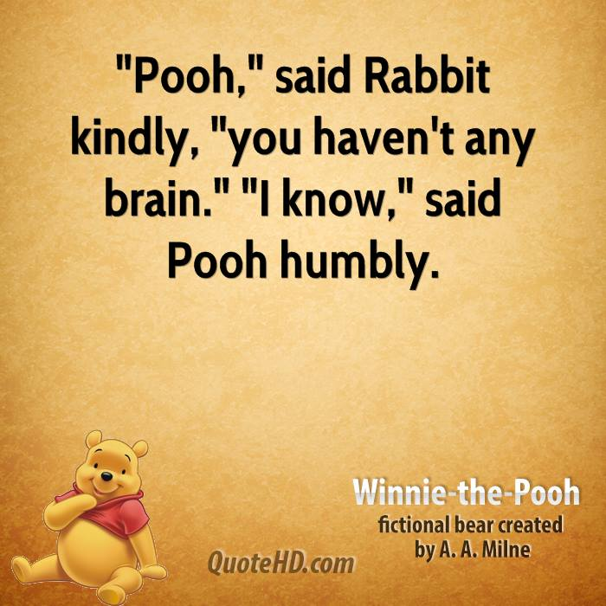

Unit Two - The Brain
Overview
This unit presents an overview of the brain, and its role in behavior and mental processes. The brain is incredibly complex, and what students will be introduced to a beginning of what we know and how it works to produce even the most basic of behaviors.

Curricular Competencies
- explain the basic parts, processes, and functions of the brain
- explain historic and contemporary research strategies and technologies that support research
case studies, split-brain research, imaging techniques (e.g., MRI, fMRI, PET, etc.).

Intro - handout: Why do Zombies Love Brains?

Read - Chapter 17, pages 279-285 (PACI)
- Chapter 3, pages 31-33 (PMS)

Notes - Your Guide To The Brain – PowerPoint
- With embedded videos
- Students take notes in space provided on handout

Activity - Split brain demo

Mnemonics - Handout to study with – Brain Parts Mnemonics
- includes note cards
Poster Assignment
- Brain parts superhero assignment
- Rubric
- Refer to examples posted in class
- Students present to class

Synthesis - One or two of the following assignments
    - Brain parts assignment - driving
    - Excuse chart
    - Biological bases of behaviour: brain scenarios

Review - Kahoots to review

Test

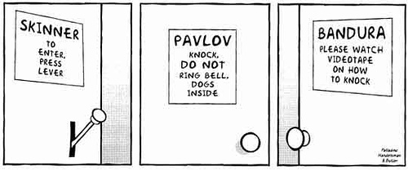

Unit Three - Learning
Overview
This unit explores the learning process of human behavior. Students will examine the basic processes needed in order for learning to occur. This unit will focus on classical conditioning and operant conditioning. Classical conditioning shows how associations form between stimuli and learning whereas operant conditioning shows how consequences inform our behaviors, leading to us learning desirable behaviors.

Curricular Competencies
- explain, compare and contrast classical conditioning, operant conditioning, and observational learning
- describe basic classical conditioning phenomena, such as: acquisition, extinction, spontaneous recovery, generalization, and discrimination,
- explain the effects of operant conditioning (e.g., positive reinforcement, negative reinforcement, punishment, schedules of reinforcement).
- describe the essential characteristics of insight learning, latent learning, and social learning.
- identify key contributors in the psychology of learning (i.e. A. Bandura, I. Pavlov, B. F. Skinner, E. Thorndike, E. Tolman, and J. B. Watson).

Read - Chapter 5, pages 67-83 (PACI)
- Chapter 7, pages 72-78 (PMS)

Notes - PowerPoint introduction to learning; Classical conditioning
  - Students take notes in space provided on handout

Activity - What have I learned?
- Hopping Activity (with partner)

Assignment - Nobel prize.org; learning
  - go to website and complete worksheet
- Classical Conditioning Practice & Classical Conditioning Processes worksheets

Activity - Classical Conditioning Demonstration with water gun

Notes - PowerPoint: Operant conditioning
  - Students take notes in space provided on handout

Assignment - Identify behavior as reinforcement/punishment; positive/negative and Schedule of reinforcement

Worksheet - +^{ve} and –^{ve} Reinforcement/Punishment; Schedules of Reinforcement

Notes - PowerPoint: Other Types of Learning
  - Students take notes in space provided on handout

Assignment - 6.3 Learning by Observation

Activity - Learned Helplessness with anagrams
- “Learning Project” – teach something to the class

Review - Classical or Operant Conditioning? Worksheet
- team challenge – 32 questions; word bank on board

Test

Unit Four – Thinking and Problem Solving

Unit 4 Overview
This unit explores how humans think. Students will explore the difference between creative and critical thinking. Students will learn different problem solving and decision making process and strategies and their applications.

Curricular Competencies
- Define the thinking process.
- identify problem-solving strategies as well as factors that influence their effectiveness.
- Understand the process of thought organization.
- Apply the steps of the problem solving process and recognize the barriers faced.
- List the characteristics of creative thought and creative thinkers.
Read - Chapter 6, pages 92-97 (PACI)
- Chapter 5, pages 52-58 (PMS)

Notes - PowerPoint: Thinking (Cognition) Introduction
  - With embedded videos
  - Students take notes in space provided on handout
  - Activities (embedded in PowerPoint)
    - U2 problem
    - What is a concept
    - Prototypes

Notes - PowerPoint: Problem Solving
  - Students take notes in space provided on handout
  - Activities (embedded in PowerPoint)
    - The Tale of Two Pebbles
    - Heuristics problems
    - Mental Set problem
    - Functional Fixedness problems
    - Princeton Bat problem

Notes - PowerPoint on Decision Making

Notes - PowerPoint on Creative thinking
  - Students take notes in space provided on handout
  - Activities (embedded in PowerPoint)
    - Uses of a Brick
    - Name Things That….
    - The Torrance Test

Activity - Cognition Stations

Review - Problem Solving Review Sheet

Test

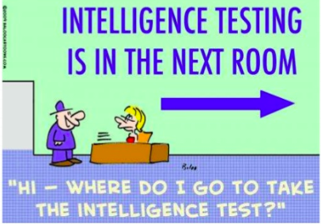
Unit Five – Intelligence and Testing

Unit 5 Overview
This unit presents an overview of what intelligence is, the original purpose of assessment, and how intelligence is measured. It will look at different ways we can be intelligent, and how it can be measured. The unit will explore testing validity.

Curricular Competencies
- describe the original purposes of psychological assessment and why they are used today.
- identify the methods used to assess individual differences.
- evaluate reliability and validity of tests.
- compare and contrast the major theories of intelligence.
- analyze the various factors that contribute to intelligence (environment, culture, prenatal, biological).
- understand IQ score applications.
- define intelligence and list characteristics of how psychologists measure intelligence:
- explain how culture influences the definition of intelligence.
- compare and contrast historic and contemporary theories of intelligence
- identify key contributors in intelligence research and testing

Read - Chapter 8, pages 119-134 (PACI)
- Chapter 11, pages 136-146 (PMS)

Intro - Test Your Mental Acuity test

Notes - PowerPoint on Intelligence and Testing (incl. emotional intelligence)
  - Students take notes in space provided on handout
  - Embedded Quiz – Stanford Binet example

Handout - sample IQ questions

Assignment - Gardner’s Multiple Intelligences ‘report’

Handout/ - Multiple Intelligences (graphic) side one
Assignment - Famous people – side two

Video - Testing and Intelligence – learner.org

Notes - Extremes of Intelligence PowerPoint
- Students take notes in space provided on handout

Assignment - Extremes of Intelligence report
- Present to class

Activity - Intelligence and Testing Webquest

Review - Review question sheet (14 q’s)
- terms sheet

Test

Unit Six – Personality

Unit 6 Overview
In this unit, students will explore major theories of how humans develop enduring patterns of behavior and personal characteristics that influence how others relate to them. It will look at the multiple causes of behavior, and how behavior can be shaped by cultural heritage. The unit also addresses research methods used to assess personality.

Curricular Competencies
- compare and contrast the major theories and approaches to explaining personality:
- describe and compare research methods (e.g., case studies, surveys, etc.) that psychologists use to investigate personality.
- describe frequently used assessment strategies (e.g., the Minnesota Multiphasic Personality Inventory [MMPI], the Thematic Apperception Test [TAT], etc.), and evaluate relative test quality based on reliability and validity of the instruments.
- identify key contributors to personality theory

Read - Chapter 9, pages 135-153 (PACI)
- Chapter 10, pages 124-133 (PMS)

Intro - Video – The Self (learner.org)

Notes - PowerPoint on Personality
  - Students take notes in space provided on handout
  - Embedded Activity: word association
  - Embedded Story : The Story of Oedipus

Assignment - Defense Mechanisms Problems – worksheet
- Defense Mechanisms Poster assignment

Activity - Briggs Myers Personality type quiz – on line
- Personality trait quiz – on line (psychcentral)
- Type A or Type B quiz

Assignment - Assessing Personality worksheet

Project - Who Are You? Poster

Review - Crossword Puzzle

Test
Unit Seven – Abnormal Behaviour (time dependent)

Unit 7 Overview
In this unit, students examine the nature of common challenges to adaptive functioning. This section emphasizes formal conventions that guide psychologists’ judgments about diagnosis and problem severity. We will look at what normal behavior is, and how it is measured, as well as how behavior is influenced by nature and nurture.

Curricular Competencies
- describe contemporary and historical conceptions of what constitutes psychological disorders.
- Categorize the major types of psychological disorders
- define and explain the role of the Diagnostic and Statistical Manual of Mental Disorders (DSM)
- discuss the major diagnostic categories and their corresponding symptoms
- explain the strengths and limitations of various approaches to explaining psychological disorders
- identify the positive and negative consequences of diagnostic labels

Final Project
Students will have a variety of projects to choose from to demonstrate their understanding of the course content. Some class time will be provided, however, personal time will be needed in order to complete the projet.

Course Review

- Course review sheet (12 page handout of course synopsis)
- Review question sheet (61 questions) – work on on own time, for review purposes
- Crossword Puzzles
  - types of psychology
  - the brain
  - brainy puzzle
  - leaning
  - personality theory

Final Exam

